LIVE WIRE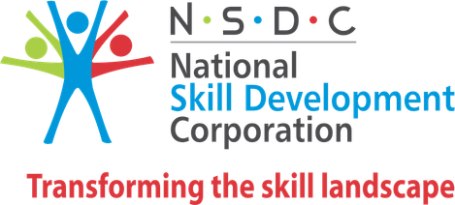 

Skill India

CERTIFICATE
Of Completion
In : Course on Python 
Awarded to : Harani S.R
At : Livewire – Mayiladuthurai Kamarajar Salai
During : 21-jun-2023 Student Id : CO230621Z382884

UMAMAKESHWARI SIVASUBRAMANIYAN 07-jun-2023

Managing Director Centre Head Date Of Issue

This is a computer generated certificate.for more details,Please verify at http://www.livewire .com/certificateverification.php
NASSCOM | NIELIT | Blockchain Council | CompTia | ORACLE | SIEMENS
LIVEWIRE offer courses thst are comprehensive and of high quality,the participation are trained by well experienced instructuion in the latest technology.
LIVEWIRE logo are registered trademarks of CADD centre training services private limited.all other brand logos are belong to the respective owners .

Topics Covered : Python


Corporate office:
1st floor,no.25,dr.radhakrishnan salai,mylapore
Chennai 600004.india.www.livewireindia.com
Livewire is a division of CADD a NSDC approved training partner

